Biology for life
Bilogy department (Namungoona salaf)

1.Two herbivores species A and species B were introduced in an ecosystem and the populations of the two species were monitored at different time interval. The results were shown in the table below

Table 1
Time ( days) | Population
Time ( days) | Species A | Species B
0 | 50 | 50
1 | 100 | 50
2 | 150 | 80
3 | 500 | 200
4 | 600 | 300
5 | 600 | 300

a) In the space provided, draw a graph for the results

a) Which species is more Adapted in the ecosystem.Give a reason for your answer
...............................................................................................................................................................................................................................
..............................................................................................................................................................................................................................
b) Describe the shape of the curve for species A
...............................................................................................................................................................................................................................
..............................................................................................................................................................................................................................
...............................................................................................................................................................................................................................
..............................................................................................................................................................................................................................
c) Give an explanation for the change in population of species A over time

...............................................................................................................................................................................................................................
..............................................................................................................................................................................................................................
..............................................................................................................................................................................................................................
7...............................................................................................................................................................................................................................
.............................................................................................................................................................................................................................
...............................................................................................................................................................................................................................
d) A natural predator of species A was introduced into the ecosytem.Explain how the changes in population of species A and B will vary
...............................................................................................................................................................................................................................
..............................................................................................................................................................................................................................
...............................................................................................................................................................................................................................
..............................................................................................................................................................................................................................
2 The figure below illustrates an experiment to demonstrate a certain biological process in yeast cells.Before addition of yeast suspension glucose was first boiled and then cooled.The gas produced in tube A was passed through a delivery tube and formed bubbles in lime in tube B
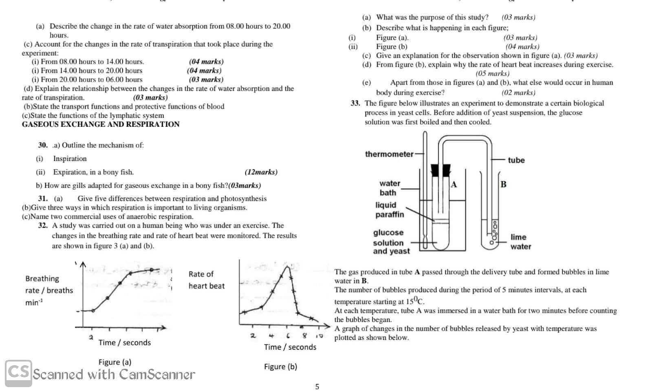
a) What biological process was being investigated in the experiment above

...............................................................................................................................................................................................................................
..............................................................................................................................................................................................................................
b) What observation would u make in lime water a few minutes after the experiment
..............................................................................................................................................................................................................................) ii) Explain the observation made in b i) above

..............................................................................................................................................................................................................................
...............................................................................................................................................................................................................................
..............................................................................................................................................................................................................................
...............................................................................................................................................................................................................................
c) Explain why
i) Glucose was boiled
...............................................................................................................................................................................................................................
..............................................................................................................................................................................................................................
ii) Glucose was cooled before adding yeast
...............................................................................................................................................................................................................................
..............................................................................................................................................................................................................................
iiI) Layer of liquid paraffin was placed over the reaction mixture
...............................................................................................................................................................................................................................
..............................................................................................................................................................................................................................
d) list any two industrial uses of the process that is being demonstrated in the experiment
...............................................................................................................................................................................................................................
..............................................................................................................................................................................................................................
3. The figure below shows the route taken by blood around the mamalian body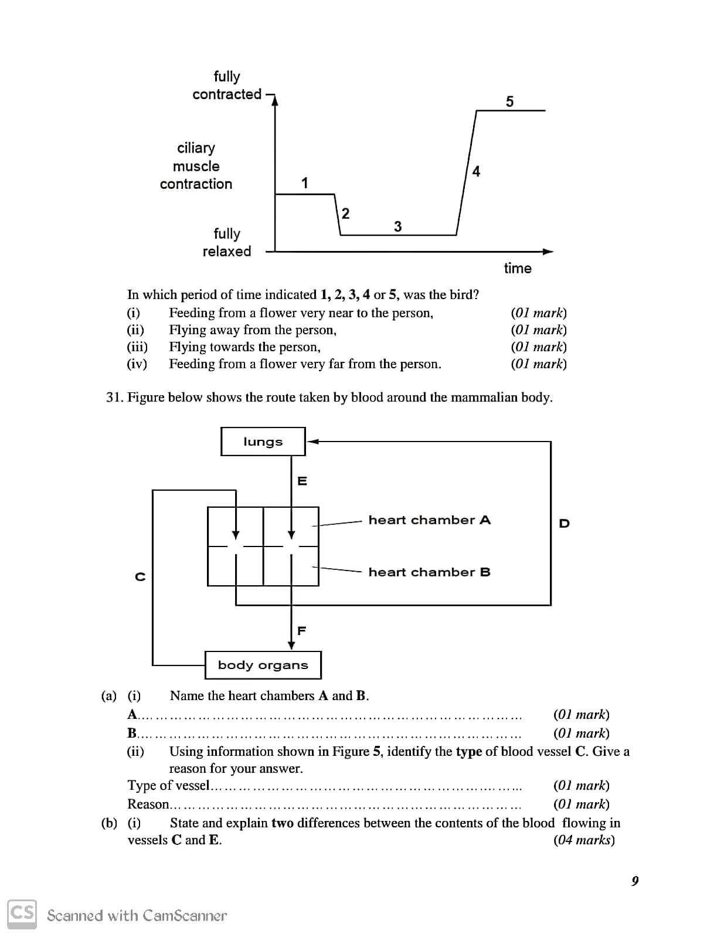
ai) Name the heart chambers A and B
A...............................................................................................
B.................................................................................................
ii) Using the information shown in the figure, identify the type of blood vessel c and give a reason for your answer
Type of blood vessel.........................................................................................................
Reason................................................................................................................................................................................................................
bi) State and explain two differences between the contents of blood flowing in vessel C and E
...............................................................................................................................................................................................................................
..............................................................................................................................................................................................................................
...............................................................................................................................................................................................................................
..............................................................................................................................................................................................................................
ii) Suggest and explain which of the blood vessel contains blood at the highest pressure
...............................................................................................................................................................................................................................
..............................................................................................................................................................................................................................

Keep home, avoid crowded areas
Always put on a protective safety mask in case your moving

